**Computer Networks**

**End-Semester Examination**

**Time: 2 hours Full Marks: TBA**

1. Answer the following questions briefly (within 20 words): [1 x 10 = 10]
2. Define DC component in a signal.
3. A network on the Internet has a subnet mask of 255.255.240.0. What is the maximum number of hosts that it can accommodate?
4. What is a peer-to-peer network?
5. What is attenuation?
6. In an (n, k) block ECC, what do n and k represent?
7. What is *p* in p-persistent CSMA?
8. Convert the IP address whose hexadecimal representation is C22F1582 to dotted decimal notation.
9. What is the function of an Internet Daemon (inetd)?
10. Give one scenario where the urgent flag in the TCP header is used.
11. What is meant by SLA (Service Level Agreement)?
12. Answer the following questions briefly (within 30 words). Draw neat diagrams where applicable. [2 x 5 = 10]
13. How is anycast routing different from multicast routing?
14. What does a IP pseudo-header contain and why is it included in the checksum?
15. What is the advantage of sliding-window flow control compared to stop-and-wait flow control?
16. What is the difference between *strict source routing* and *loose source routing*?
17. What are the assigned ports for the following protocols: (i) SSH, (ii) HTTP? What assigned ports do the following protocols map to: (i) 443, (ii) 25?
18. Answer the following questions:
19. Given the narrow (usable) audio bandwidth (3000 Hz) of a telephone transmission facility, a nominal SNR of 56dB (400,000), and a certain level of distortion: [2+2]
20. What is the theoretical maximum channel capacity (kbps) of traditional telephone lines?

(ii) What can we say about the actual maximum channel capacity?

1. Given a receiver with an effective noise temperature of 294K and a 10-MHz bandwidth, what is the thermal noise level at the receiver output? [Boltzmann constant = 1.38 x 10-23] [2]
2. Consider an audio signal with spectral components in the range 300 to 3000 Hz. Assume that a sampling rate of 7000 samples per second will be used to generate a PCM signal. [2+2]
3. For SNR = 30 dB, what is the number of uniform quantization levels needed?
4. What data rate is required?
5. Answer the following questions:
6. Suppose that for an ISDN (integrated services digital network) with a 64-kbps channel, 1 frame with undetected error is expected per day. Assuming that the frame length is 1000 bits: [2+2]
7. What is the probability that a frame is received with an undetected error?
8. If the actual bit error rate is 10-6, is it possible to achieve a probability close to that achieved in (i)? Compute.
9. Two communicating devices are using a single-bit even parity check for error detection. The transmitter sends the byte 10101010 and, because of channel noise, the receiver gets the byte 10011010. Will the receiver detect the error? Why or why not? [1]
10. Sixteen-bit messages are transmitted using a Hamming code. How many check bits are needed to ensure that the receiver can detect and correct single-bit errors? Show the bit pattern transmitted for the message 1101001100110101. Assume that even parity is used in the Hamming code. [1+3]
11. Calculate the Hamming distances among the following pairs of code-words: [1]  
    (i) (00000, 10101) (iii) (01010, 10101)
12. Answer the following questions:
13. The distance from earth to a distant planet is approximately 9 × 1010 m. [2+2]
14. What is the channel utilization if a stop-and-wait protocol is used for frame transmission on a 64 Mbps point-to-point link? Assume that the frame size is 32 KB and the speed of light is 3 × 108 m/s.
15. Suppose a sliding window protocol is used instead. For what send window size, will the link utilization be 100%? You may ignore the protocol processing times at the sender and the receiver.
16. A large population of ALOHA users manages to generate 50 requests/sec, including both originals and retransmissions. Assume that time is slotted in units of 40 msec. [1+1+1]
17. What is the chance of success on the first attempt?
18. What is the probability of exactly k collisions and then a success?
19. What is the expected number of transmission attempts needed?
20. Two CSMA/CD stations are each trying to transmit long (multi-frame) files. After each frame is sent, they contend for the channel, using the binary exponential back-off algorithm. What is the probability that the contention ends on round k, and what is the mean number of rounds per contention period? [1.5+1.5]
21. Answer the following questions:
22. Consider the following arrangement for implementation of the *Chord* protocol (larger circles represent the actual machines):

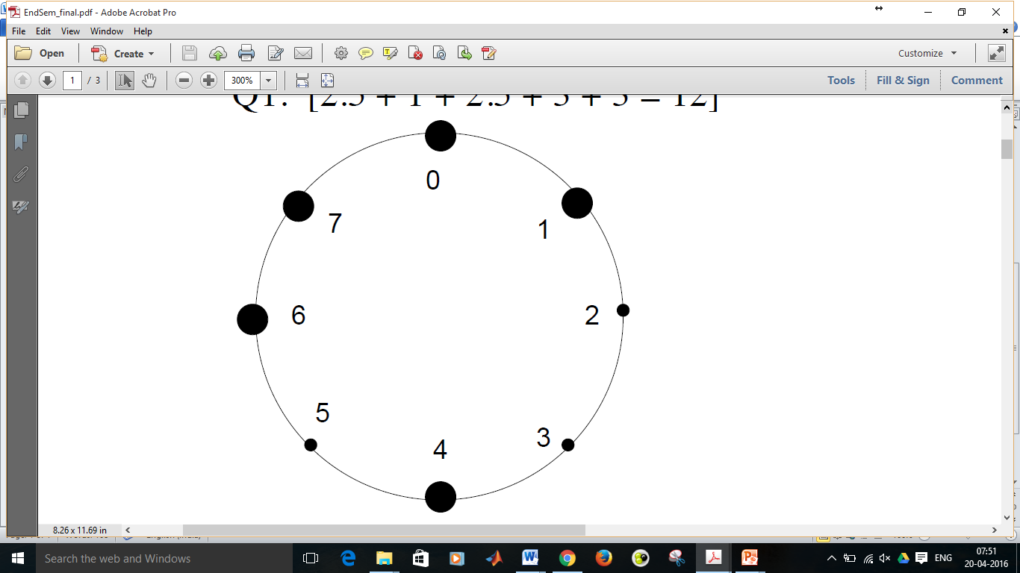

1. Construct the finger table for the nodes 0, 1, 4, 6, 7 (assume that the node identifier consists of 3 bits). [2.5]
2. Show the visited nodes and intermediate steps when one searches for key value 6. Assume that the search has started from node 0. [1.5]
3. State three problems of Network Address Translation (NAT). [3]
4. Consider the network shown below. Distance vector routing is used, and the following vectors have just come in to router C: from B: (5, 0, 8, 12, 6, 2); from D: (16, 12, 6, 0, 9, 10); and from E: (7, 6, 3, 9, 0, 4). The cost of the links from C to B, D, and E, are 6, 3, and 5, respectively. What is C’s new routing table? Give both the outgoing line to use and the cost. [3]

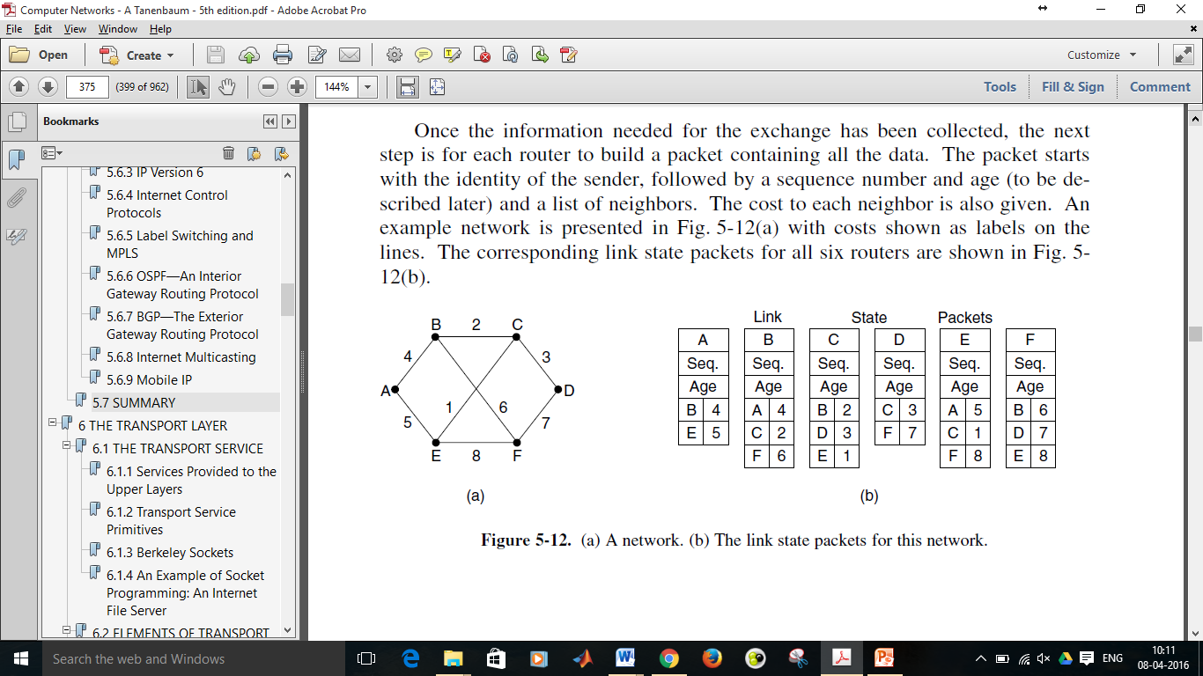

1. Answer the following questions:
2. What is a care-of-address in the case of routing for mobile hosts? Explain how packets are routed from a sender to a mobile host who has moved out from his home network. [1+2]
3. A computer on a 6-Mbps network is regulated by a token bucket. The token bucket is filled at a rate of 1 Mbps. It is initially filled to capacity with 8 megabits. How long can the computer transmit at the full 6 Mbps? [3]
4. The 14th byte (bit positions 105-112) of a TCP header consists of 8 flags of size 1-bit each. State any 4 of them and explain in one sentence each. [4]
5. Answer the following questions:
6. If the TCP round-trip time, RTT, is currently 30 msec and the following acknowledgements come in after 26, 32, and 24 msec, respectively, what is the new RTT estimate using Jacobson’s algorithm for *Smoothed round-trip time* (SRTT) computation? Use α = 0.9. [2]
7. Suppose that the TCP congestion window is set to 18 KB and a timeout occurs. How big will the window be if the next four transmission bursts are all successful? Assume that the maximum segment size is 1 KB. [2]
8. Consider a telnet connection to an interactive editor that reacts on every keystroke. What would be the worst-case overhead of sending one character assuming TCP connection (consider only TCP and IP headers)? Briefly describe the algorithm which solves this problem. [2+2]
9. What are the 4 possible connection release scenarios in the transport layer? Support your answer with neat diagrams. [2]